# Optimizing SPM:

1. SPM limits the amount of RAM it is allowed to use at once during model estimation. This obviously slows things down. It can be changed.
   1. Make this change in SPM. There is a variable in spm_defaults.m called defaults.stats.maxmem This is set, by default, to 2^30 (which is 1GB). Changing this to be closer to the amount of RAM we have on hand and it will make a significant difference. For reference, 2^33 is 8 GB.
2. SPM also has a setting which determines whether temporary files it generates during model estimation are written to disk or stored in memory.
   1. Make this change in SPM. This is a variable in spm_defaults.m called defaults.stats.resmem If it is set to true, the temp files will be kept in RAM. If it is set to false, they will be written to disk. Set it to true

## A few notes on the SPM GUI

Rec: The “rec” option in the select files window means “recursively,” if you specify a filter, rec will select all matching files

**^**: Using this symbol in the filter delineates the beginning of the filter phrase, e.g. ^KAHN* would return all KAHN---nii files, and not wra, ra, or a files (while KAHN* would)

* Means default

# Moving & Converting files

Transfer data from pen drive to subject directory. Once the data is transferred use MRIconvert to convert the dicom files to .nii files. In MRIconvert, select NIFTI as the file type to convert to. Choose ‘Add folder’ in ‘DICOM series to convert and select the subject. Choose the subject directory as the Nifti directory as well**.**

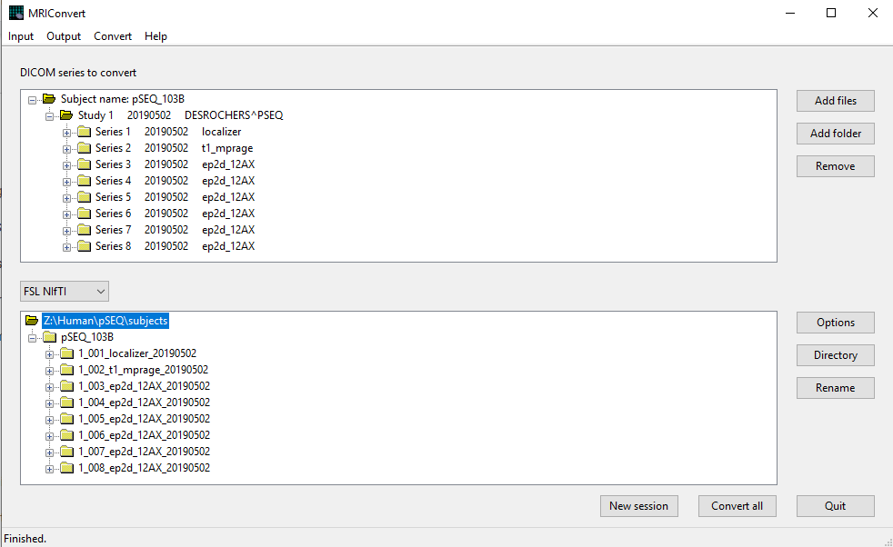

Under the Output, Options menu, select (scroll to select items further down in the menu):

* 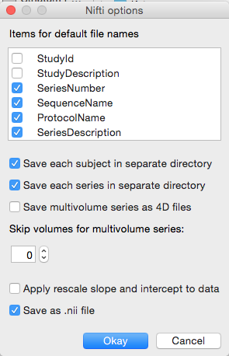Patient Name
* Series Date
* Series Time
* Series Number
* Sequence Name
* Protocol Name
* Series Description

Once the conversion is done, move the raw data to the dicom directory and re organize folders if needed so that the newly generated folders from the conversion step are in the main subject directory.

## Put files in Folders:

Once .nii files have been added, the files need to be reorganized before further analyses. Files should be in the following structure inside the study folder eg: /.../<studyname>/subjects/

* SubjectNumber (e.g. 101)
  + anatomy
    - aa_scout
    - localizer
    - t1end
    - t1mprage
  + behavioral
  + bold
    - folder for each run (001, 002, etc.)
  + dicom
  + resting (if necessary)

**Sort and organize files and folders with a script**

1. Run the following function in Matlab:
2. Script: >> td_file_sort(subjnum, subjectdir, anums, fnums, rnums)
   1. Example: td_file_sort('C:\Users\lab\Documents\MRI_data', 3, [1 2 17], 3:16, 3:16)
      1. subjnum = the number of the subject, e.g. 101
      2. subjectdir = the full path of the folder where all the subject data is kept
      3. anums = the series numbers of the anatomical scans, e.g. [1 2 10]
      4. fnums = the series numbers of *all* the functional runs, e.g. [3:9]
      5. rnums = the series numbers of the functional runs to include for analysis (run numbers)
3. **KEEP IN MIND:** Some times the files that come from the MRI are labeled with just the subject number as the prefix (for e.g. ‘3’), sometimes there’s one zero before (for e.g. ‘03’), sometimes there’s multiple zeroes before (for e.g. ‘003’). Based on the filenames, the script will or won’t work. **There’s a variable called subj_prefix on line 120 – make this match whatever the prefix happens to be for this batch of data.**

## Transfer behavioral files to newly created ‘behavior’ folder

td_file_sort creates a “behavior” folder in the subject folder. The behavioral data should already be on the L drive, copy these files to the behavior folder in the subject directory.

# Data quality check

In this section, you will look at various aspects of the data within a given run. tsdiffana will return scaled variance, slice by slice variance, scaled mean voxel intensity, and maximum and minimum slice variance. art_global will return the global mean (a graph identical to the one produced by tsdiffana in scaled mean voxel intensity), the STD of all the data, and an estimate of movement.

## Examining the anatomical image (usually t1 mprage)

1. Open Matlab
   1. start SPM12
   2. >> spm fmri
2. Verify that the vitamin E capsule is on the right in the t1mprage
   1. On the SPM12: Menu
   2. Go to the Display button
   3. Navigate (using single clicks!) to the anatomy/…t1_mprage_... folder
   4. Single click the file to show it selected in the bottom pane
   5. Click “Done” to display the image
   6. Scroll through the image and make sure everything looks good and the vitamin E shows on the right. Look for dropout or other artefacts and abnormalities. Take any necessary notes.

## Examine 2 EPI imgs from the functional runs

1. Go through two of each of the functional runs to make sure the epi sequences look the way they should
2. Script: >>td_displayImages(basedir, subjnum, runs, imgtype)
   1. Example: >> td_displayImages(‘C:\Users\lab\Documents\MRI_data', 3, 1:14, ‘f’)
      1. subjnum = subject number, e.g. 3
      2. runs = runs that want to randomly draw 2 images from, e.g. 1:14
      3. imgtype = the prefix of the type of images you want to see, e.g. ‘f’ for the raw functional data
      4. Will require you to hit “n” to go to the next image or “x” or exit
3. Make note of the following:
   1. Runs that have dropout in the bold. Men usually have more dropout.
   2. Runs that have ghosts in the bold
      1. For those runs that have ghosts, make note of the ghost:noise ratio. Use the cursor to find the value in the title bar for the ghost, and then the same for the noise. Calculate and make note of the ratio. 10:1 ghost:noise ratio is okay, 2:1 or less is best; motion can cause ghosts. Ventral ghosts around the eyes seem pretty typical.
   3. Paste all these things into the preprocessing notes document

## Find Raw SNR Estimate

1. Script: >>td_CheckSNR
   1. Example: >> AllSNR = td_CheckSNR('C:\Users\lab\Documents\MRI_data\3\bold', 5, {'001' '002' '003' '004' '005' '006' '007' '008' '009' '010' '011' '012' '013' '014'})
      1. MRI_path: Directory string for all MRI data
      2. Subjnum: subject number
      3. rundirs: Cells containing bold run numbers. Example for how to run this is shown below.
   2. Take the mean of AllSNR: mean(AllSNR)
      1. Add the raw SNR estimates to this [spreadsheet](https://docs.google.com/spreadsheets/d/1PGZnLUOUsUqm9p6RUtbSU7vkes8DTwMJYv4NDFidRIM/edit#gid=0)

## Data Quality Checks

1. Script: >>td_dataQualCheck(subjpath, subjnum, runnums, f-prefix, make_table)
   1. Example: >>td_dataQualCheck(‘/Users/aaritahuja/Documents/Lab/MRI_data’, 3, 1:14, ‘f’, 1)
      1. subjpath = path where all subjects are located
      2. subjnum = subject number
      3. runnums = a vector with the functional runs listed
      4. f-prefix = a string indicating the prefix of the files to look for
      5. make_table = yes (1) or no (0) whether to make table outputting values
   2. Might have to adjust the script for your data by changing directory in first lines of script
2. After displaying the three figures for a run, it will print out the number of files for that run and wait for an input as to what to do next:
   1. n – closes the open figures and generates figures for the next run
   2. o – leaves the current figures open and generates figures for the next run
   3. x – escapes the function
3. 1st Figure: This program takes the variance of signal in a whole volume and compares what that volume looks like relevant to variance in the previous volume.A spike in a graph indicates a big variance change, scale gets very large – please see tsdiffanaartglobal.doc (go to the appendix at the end) for sample graphs of what is acceptable and not.
   1. First graph: Volume to volume variance - **the scale of this graph goes in the Variance column** (see table below), also note what image number if there is one with particularly high variance
   2. Second graph: Slice by slice variation, greater variance in more ventral regions; when there is a spike in graph one, is there one or many Xs in the second graph? One X means that one slice is different from the rest, probably as a result of a spark. Many Xs lined up suggest the entire volume is different from the rest. “Confetti” is a clue to movement
   3. Third graph: Mean voxel intensity/mean signal, best case scenario would yield a straight line at 1. **Note positive or negative slope in Drift column**
   4. Fourth graph: Slice variance, note range of variance and slice with the highest variance ; typically more variance in earlier slices which are OFC/etc regions. Change can either be transient or consistent, **transient is implicated by a large red line** (high value for maximum), consistent is implicated by a large black line (high value for median). **Note the range and the Max Var from this graph**.
4. 2nd Figure (art_global)
   1. First graph: Global mean, same as the scaled mean voxel intensity in tsdiffana, though scaled differently (scaled to mean signal versus previous in tsdiffana which scaled to previous volume)
   2. Second graph: One image is compared to all the other images; red line indicates threshold, looks for outliers. **Record what the STD of data is, as well as the default current threshold.** Move the red line down (or up) until it hits a point and gives a new STD. **Record the new current threshold** and the point at which this occurs
   3. Third graph: Extent of movement. Ideal is less than 1 voxel of movement. **Record the range of this graph in Movement column**. If there are spikes in certain volumes, write down whether that spike was probably caused by movement (see third graph) and which type of movement. Then look at those volumes using biac movie. This program takes second image and gives the difference between that volume and all others. In using biac movie you are looking for extra activity that shows up on only one volume, particularly the slice which had the big spike in tsdiffana and art_global.
5. 3rd Figure (art_movie): Rimming, blue and yellow coloring around the edges of the brain, around the brain could be due to movement. See Examples of Good and Bad Data at the end of this manual.

|  |  |  |  |  |  |  |  |
| --- | --- | --- | --- | --- | --- | --- | --- |
| Run | Variance | Drift? | Max/Min Var | STD | Threshold | Adjusted | Movement |
| 1 | 0-2 | + | 5, 0 | 2.8465 | 4.5 | 3.2 | -0.1, 0.1 |
| 2 | 0-4, 70 | + | 3, 0 | 3.2179 | 5.5 | 4.4 | -0.1, 0.1, x |
| 3 | 0-2 | + | 4, 0 | 2.9316 | 3.7 | 2 | -.05, .05 |
| 4 | 0-1 | slight | 3, 0 | 2.4315 | 6.2 | 5.3 | -.05, .05 |
| 5 | 0-3, 29 | none | 2, 0 | 2.2884 | 4.3 | 3.8 | -.05, .05, y |

# Pre-processing

## Batch Pre-processing with script

1. Script: >> td_prepro(subjpath, subjnum)
   1. Example: >>td_prepro(‘C:/Users/lab/Documents/MRI_data’, 8)
   2. See the header comments in td_prepro.m for more details on how to set options and outputs.
   3. Might be useful to open SPM first
   4. **The anatomy folder with the t1 mprage file in it should be called “t1_mprage”, and the file name also needs to end in “t1_mprage”. This should occur in the file sorting step, but in case it does not, it can also be done manually.**
   5. **On lines 293 and 485, there are hardcoded directories for a TPM.nii file : check them before you run to make sure they make sense for the computer that you’re working on.**
   6. After processing completes for td_prepro, evaluate the output of the Realignment step (showing in the SPM window or in the dated .ps file in the subject folder) for whether it is OK to proceed with preprocessing as-is or if it is necessary to complete Realignment run-by-run. **The basic criterion is that the estimated motion cannot exceed the size of a voxel, which is 3 mm.**
   7. If the preprocessing step does not spit out a .ps file with realignment graphs (this happens if you don’t have an SPM graphics window open at the time of running td_prepro), they can be recreated using realignment_motion_check(subjnum, subjpath).
2. Paste the Realignment graph into the Realignment section on the notes sheet. Note if you will re-do it run-by-run
3. Evaluate files from the completed preprocessing (td_prepro or td_prepro_runByRun) function
   1. Slice Timing: af* files
      1. Look at two images from each run using td_displayImages
      2. Example: >> td_displayImages(‘C:\Users\lab\Documents\MRI_data', 3, 1:14, ‘af’)
   2. Realignment: raf* files
      1. Look at two images from each run using td_displayImages
      2. Example: >> td_displayImages(3, 1:14, ‘raf’)
      3. Look at each run using td_dataQualCheck
      4. Example: >> td_dataQualCheck(101, 1:6, ‘raf’)
   3. Normalization: wraf* files
      1. Check the registration between the normalized images and the canonical brain using **“Check Reg” in SPM**.
         1. Click “Check Reg”: SPM select window will appear
         2. Select two (or more) images to compare:
            1. Any one of the functional w* images
            2. Template brain (/Documents/Matlab/spm/spm12/tpm/TPM.nii)
            3. [Optional to compare that subject’s mprage for example]

Use the normalized mprage versus raw?

* + - 1. Use the blue crosshairs to check the edges of the brain – front, back, sides. Note any differences in lab notebook.
    1. Look at two images from each run using td_displayImages
  1. Smoothing: swraf* files
     1. Look at two images from each run using td_displayImages
     2. Look at each run using td_dataQualCheck
     3. Example: >> td_displayImages(101, 1:6, ‘swraf’)

1. The t1mprage anatomical was normalized by the td_prepro function as well. Check that it was performed correctly
   1. Check the registration between the normalized t1mprage and the canonical brain using “Check Reg” in SPM.
      1. SPM select window will appear, select mean normed image (anatomy/t1mprage/w*.nii), the tissue probability map (/usr/local/spm/spm12/tpm/TPM.nii) and the canonical brain (single_subj_T1.nii in usr/local/spm/spm12/canonical)

# Skull stripping

1. In terminal: Type fsl&
2. Go to BET-Brain Extraction
3. ***Input image: Select w normalized anatomical image (anatomy/t1mprage/w*.nii)***
4. Fractional intensity threshold; smaller values give larger brain outline estimates:
   1. .2 (conservative), favors inclusion
   2. .3 (women)
   3. .25 (men)
   4. Record this parameter in the notebook
5. Advanced options
   1. Check the Output brain-extracted image box
   2. Check the Output binary brain mask image box
6. Leave the rest of the options as default
7. This should create a skull stripped image (ending in _brain.nii.gz) and a binary image (ending in _brain_mask.nii.gz) that is zipped in the same directory as w* file

## Checking the skull stripping

Before creating the final mask in step 3 below, you want to check that you don’t have too much skull or are missing brain. It is better to err on the side of caution and not have missing brain but do include a little skull. **You may have to go through an iterative process to pick the correct fractional intensity threshold.**

1. Open Mricron
2. File > Open the w image (normalized, but not the one with the skull stripped)
3. Overlay, Add the w*_brain image (note you do not have to unzip the file in order to add it as an overlay)
   1. Adjust the overlay viewing so you can clearly see what has been cut off and what is still there.
   2. Overlay, Transparency on background, 60% (or some other value)
   3. You can choose the color of the overlay on the toolbar (default is Red for the first overlay)
4. Scroll through the *entire* brain paying close attention to the edges, particularly at the very front of the brain. You are looking for any little bit of brain that is gray (not covered by the overlay of the stripped brain). **That means that part of the brain is missing from your brain mask and that is bad!**
5. Copy and rename the brain mask
   1. Copy the now unzipped w*_brain_mask.nii file and put it in the /subjects/###/anatomy folder. It is **very important** that it is in the anatomy folder, not the t1 folder.
   2. Rename the w*_brain_mask.nii file in the anatomy folder to be called “normmask.nii”. It is important that it is exactly that name (the scripts are case sensitive).

Once you have the final normmask.nii saved in the appropriate place, check it again in MRIcron using the same process as in step 2 (but overlay the normmask.nii rather than the w*_brain image). Pick a representative image and paste a screen shot (preferably from the front of the cortex) into the preprocessing notes.

# Zip or remove all the intervening processing steps

The function is: zipscript(type, foldernames, sprefix, varargin)

Make sure you change folder dir to current subject before running script or

In Matlab example:

zipscript(‘zip’, {‘001’ ‘002’ ‘003’ ‘004’ ‘005’ ‘006’}, ‘f’)

**This will zip all the f, af, raf, and wraf files. It will not zip swraf files because those are the files that you use for analysis.** Do not delete the intervening steps, unless you are *very* confident in your processing stream.

# Examples of Good and Bad Data

## tsdiffana

**A normal subject:**

Note the small scales on the first and fourth graph.

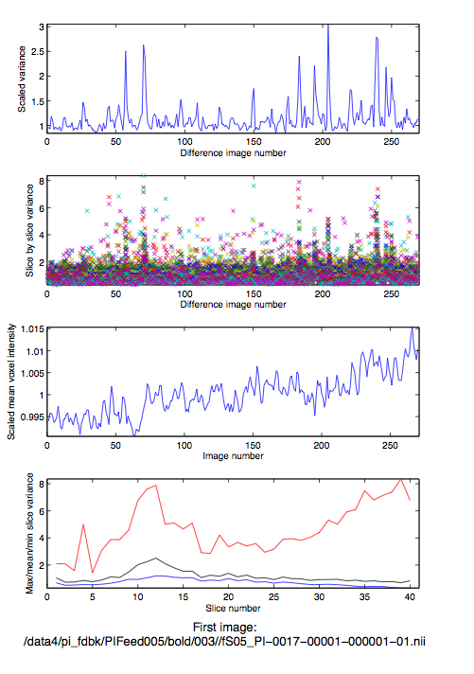**A -below-average subject:**

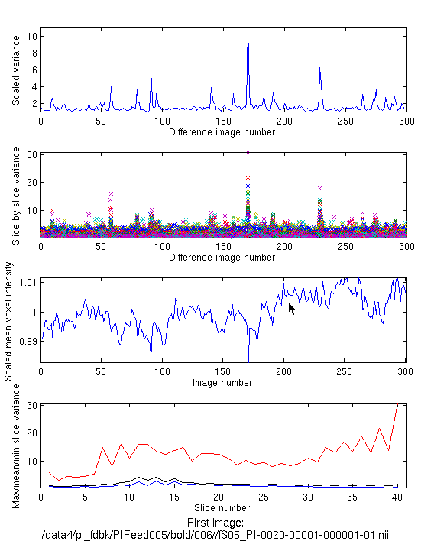

Any subjects whose runs have scales somewhere between this subject and the ideal subject will have decent motion parameters such that they will not need to be realigned run by run. Most subjects you run will probably fall somewhere between this subject and the ideal subject. Subjects with slightly larger scales on average will probably still be usable, but will probably have to be realigned run by run.

**The typical unusable subject**

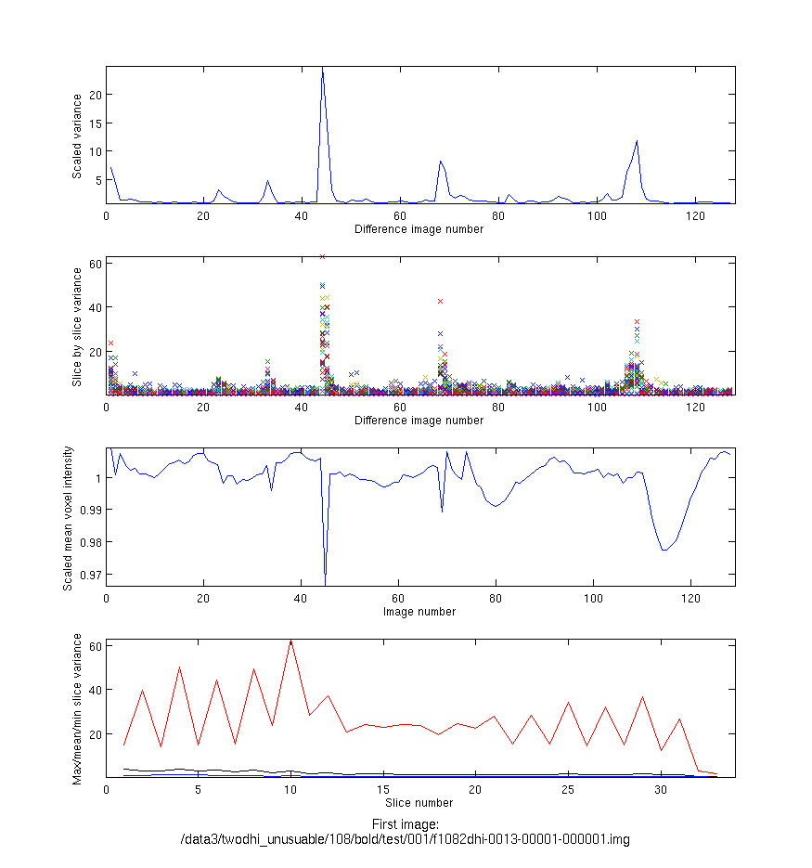

Variance (1st) graph scales ranging from 1-20 coupled with max/min (4th) graph scales ranging from 1-60 are typically unusable subjects. If this only occurs in one run and has a discrete point that can be repaired then the subject might still usable, but multiples like this are problematic.

**A for-sure unusable subject**

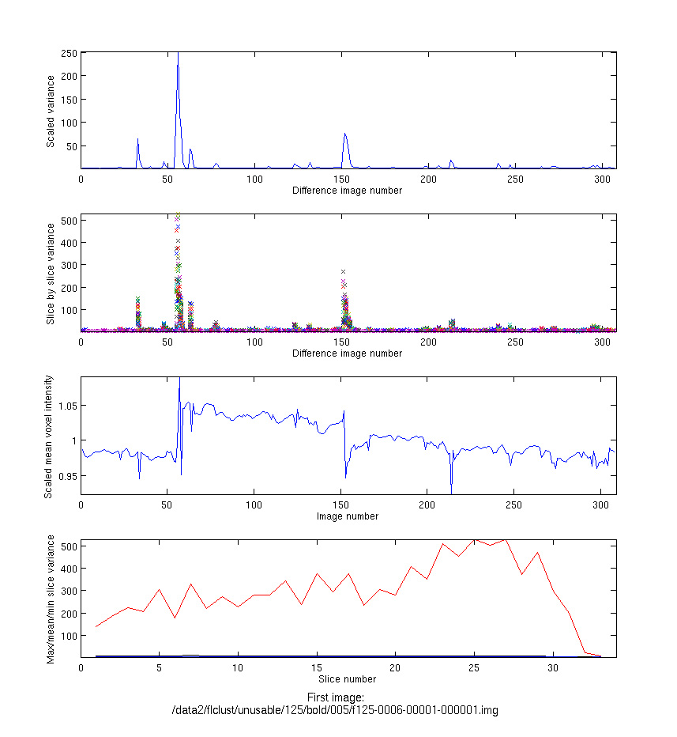

Any subject with this type of variance will be unusable. The corresponding art global graph for this run had motion scale of -5 to 5.

**Scanner error**

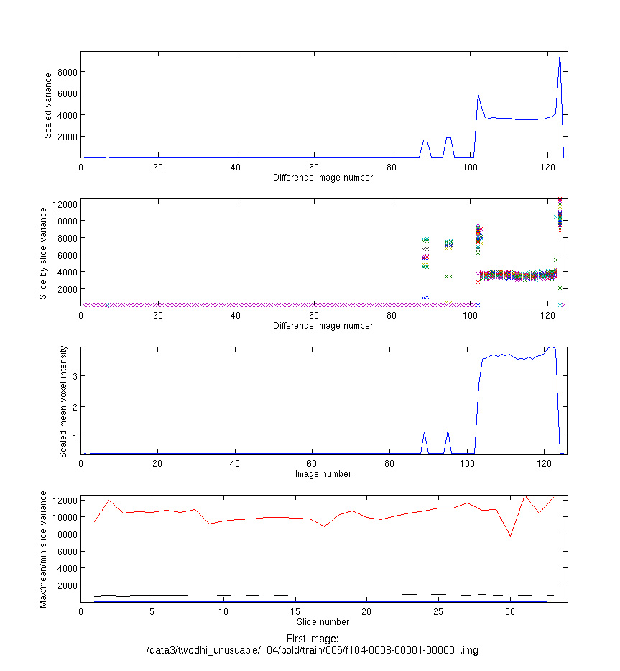

Finally, this graph shows a run during which the scanner was not working properly (apparently some wires had caught on fire). Although any larger-than-average scale (1-20, 1-200, etc) should be checked in biac movie (especially those with large spikes), odds are with a scale this large something is up with the scanner.

## art_global

This is the same run shown as an example in the ‘average subject’ in tsdiffana. First graph is similar to the first tsdiffana graph, just scaled differently. The important information to record is the StdDev of data (2.4031 in this case), current threshold (3.5) and what points the red line is currently crossing, if any. Adjust the line up or down until it first hits a point, and record the point at which the line crosses, and the adjusted threshold. The final graph shows the movement along the xyz dimensions, record the scale in the lab notebook.

